TVG Background Check Application

| Last Name: | Luong | | | | | | | |
| --- | --- | --- | --- | --- | --- | --- | --- | --- |
| First Name: | | Avis | | | | | | |
| Middle Name: | | | Tri | | | | | |
| Maiden Name (if applicable): | | | | | | |  | |
| Date of Birth: | | | 04/21/2005 | | | | | |
| Social Security #: | | | | | | 635-96-8199 | | |
| Phone Number: | | | | 469-510-8288 | | | | |
| Current Address: | | | | | 1712 Alpine Dr. Carrollton, TX 75007 | | | |
| Start and End Date at above address: | | | | | | | | 04/21/2005 - 08/11/2023 |
| Previous Address: | | | | | | N/A | | |
| Start and End Date at above address: | | | | | | | |  |

I, ____________Avis Luong__________________, hereby authorize The Vested Group to investigate my background and qualifications for purposes of evaluating whether I am qualified for the position for which I am applying. I understand that The Vested Group will utilize an outside firm or firms to assist it in checking such information, and I specifically authorize such an investigation by information services and outside entities of the company's choice. I also understand that I may withhold my permission and that in such a case, no investigation will be done, and my offer for employment will not be processed further.

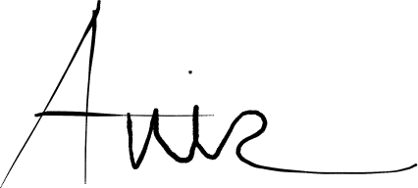

_____________________________________  _____06/23/2023_____________

Signature of Employee                              Date

____________Avis Luong____________

Employee's Name - Printed